Types of zoonotic diseases
- What is zoonosis?
- Types
- Causes
- Prevention
Zoonosis is the name given to diseases or infections that can be transmitted between humans and animals.
Many people interact with animals during their daily lives, and millions of households in the United States have pets. Other people come into contact with animals through their work, such as farming, or in the wild.
In this article, we look at the common types of zoonotic diseases and how they can be prevented.

What is zoonosis?
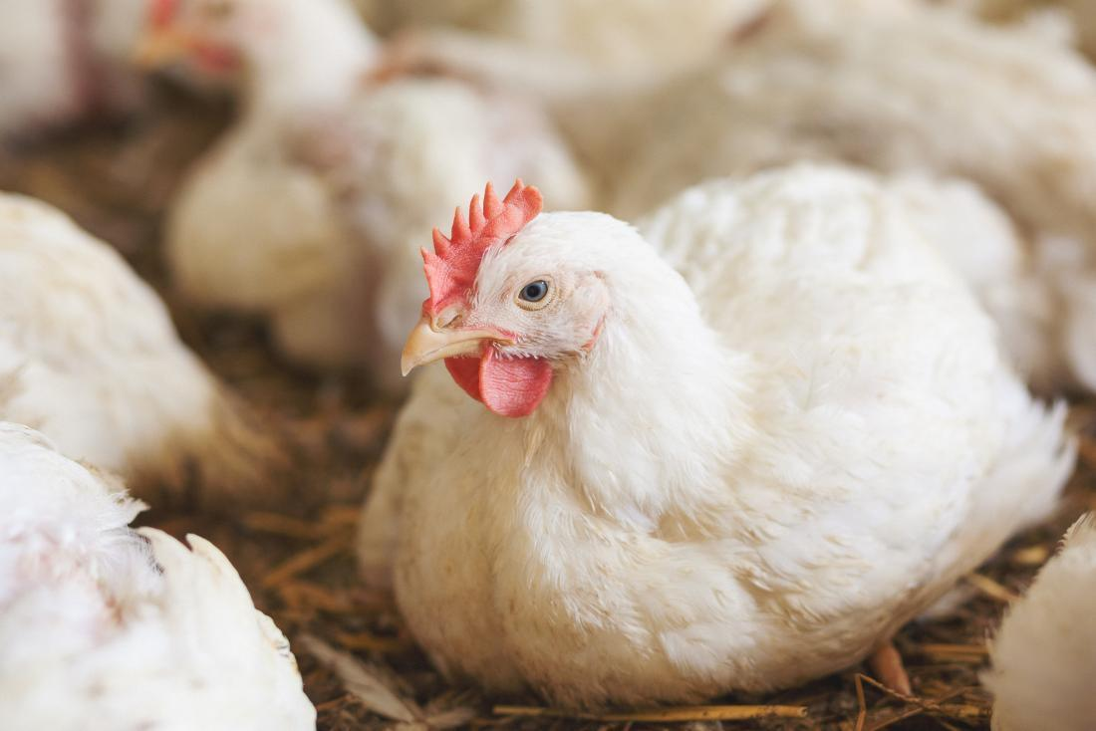Share on PinterestMany different types of animals may spread zoonotic diseases, including chickens.
Zoonosis refers to diseases that can be passed from animals to humans. They are sometimes called zoonotic diseases.
Animals can carry harmful germs, such as bacteria, fungi, parasites, and viruses. These are then shared with humans and cause illness. Zoonotic diseases range from mild to severe, and some can even be fatal.
Zoonotic diseases are widespread both in the U.S. and worldwide. The World Health Organization (WHO) estimates that 61 percent of all human diseases are zoonotic in origin, while 75 percent of new diseases discovered in the last decade are zoonotic.
Before the introduction of new hygiene regulations around 100 years ago, zoonotic diseases such as bovine tuberculosis, bubonic plague, and glanders caused millions of deaths. They are still a major problem in developing countries.

MEDICAL NEWS TODAY NEWSLETTER
Stay in the know. Get our free daily newsletter
Expect in-depth, science-backed toplines of our best stories every day. Tap in and keep your curiosity satisfied.
Enter your email
SIGN UP NOW
Your privacy is important to us

Types
Common zoonotic illnesses include:
Rabies
Rabies is a disease that affects the nervous system of mammals. It is usually caused by a virus and is transmitted if an infected animal bites a person or other animal.
Rabies is almost always fatal once symptoms appear. However, rabies vaccines exist and are commonly available.
Lyme disease and Rocky Mountain spotted fever
Lyme disease is transmitted through tick bites. Symptoms can range from mild to severe, but it can be treated using antibiotics.
Dengue, malaria, and chikungunya
These are mosquito-borne diseases and are more common in certain areas, such as the Caribbean.
Symptoms include fever, vomiting, and headaches. It is vital to treat these conditions as soon as possible, as they can be fatal.
Salmonella infection
Salmonella is often caused by handling reptiles or amphibians that carry Salmonella, or by handling baby chicks or ducks.
The illness usually lasts for between 4 and 7 days, and symptoms include diarrhea, fever, and abdominal cramps. People can usually recover without medical treatment, although conservative measures are recommended.
E. coli infection
This infection is often caused by touching infected animals or handling contaminated food. Cows also have E. coli germs on their udders.
Often associated with food poisoning, salmonella can cause vomiting, abdominal cramps, and diarrhea. It is essential that infected people rest and drink plenty of fluids.
Psittacosis
Also known as ornithosis or parrot fever, psittacosis is a bacterial disease that most often affects birds. Humans can get it from feathers, secretions, and droppings.
Symptoms include fever, headache, and dry cough. In serious cases, it may cause pneumonia and require a hospital visit.
Other types
There are hundreds of zoonotic diseases, but many are rare. Other well-known types include:
- anthrax
- avian influenza or bird flu
- bovine tuberculosis
- brucellosis
- cat scratch fever
- Ebola
- West Nile virus
- leprosy
- Zika fever
- trichinosis
- swine influenza
- histoplasmosis

Causes
Zoonotic diseases can be transferred from animals to humans in several different ways, including:

Direct contact
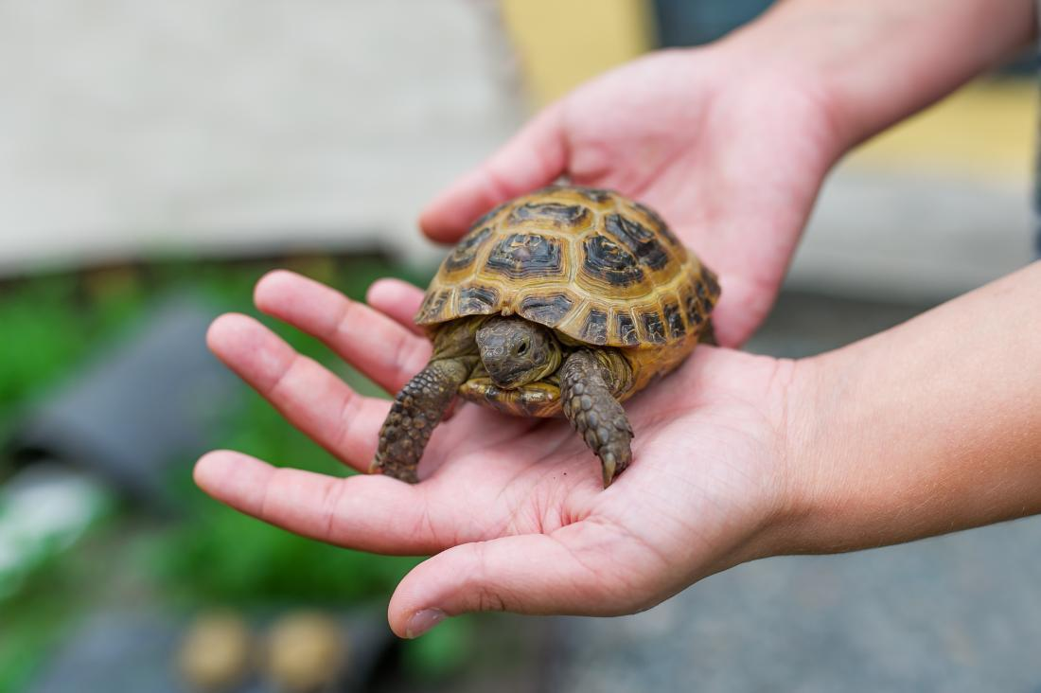Share on PinterestDirect contact is one potential cause of the spread of zoonotic diseases.
Direct contact involves coming into contact with the bodily fluids of an infected animal, such as saliva, blood, urine, mucus, or feces.
This can happen because of merely touching or petting infected animals, or being bitten or scratched by one.
Water resources that are contaminated by manure can also contain a great variety of zoonotic bacteria and therefore increase the risk of that bacteria transferring to humans.

Indirect contact
Indirect contact involves coming into contact with an area where infected animals live or roam, or by touching an object that has been contaminated by an infected animal.
Common areas where this occurs include:
- aquarium tanks
- chicken coops
- pet baskets, cages, or kennels
- pet food and water dishes
- plants and soil where infected animals have been
Farmers, abattoir workers, zoo or pet shop workers, and veterinarians have an increased risk of being exposed to zoonotic diseases. They can also become carriers and pass those diseases on to other people.

Vector-borne
A vector is a living organism that transfers an infection from an animal to a human, or another animal.
They are often arthropods. Common vectors include:
- mosquitoes
- ticks
- fleas
- lice
The vector will bite the infected animal and then bite a human, passing on the zoonotic disease.

Food-borne
Zoonosis can come from contaminated animal food products, improper food handling, or inadequate cooking.
Around 1 in 6 American people will get sick at some point in their lives by eating or drinking contaminated food or drink.
Common causes of zoonosis through food-borne include:
- unpasteurized milk
- undercooked meat or eggs
- raw fruit and vegetables contaminated with feces from an infected animal

Other causes
Global climate change, the overuse of antimicrobials in medicine, and more intensified farm settings are also thought to influence the increasing rate of zoonotic diseases.
People with a weakened immune system are also at greater risk. Common causes of immune-suppression include:
- pregnancy
- infancy
- cancer treatment
- organ transplant
- diabetes
- alcoholism
- infectious diseases, such as AIDS

Prevention
Share on PinterestPracticing good hygiene by washing hands after handling animals and before preparing food may help to prevent the spread of zoonotic diseases.
People come into contact with animals all the time, but there are several steps a person can take to help prevent infection. These include:
- Keeping hands clean: Washing hands with clean soap and running water after being around animals, even if not touching them, can stop germs spreading.
- Choosing a pet wisely: Thoroughly researching types of pets and taking steps to be safe around them can help prevent disease.
- Preventing bites from mosquitoes, ticks, and fleas: Using bug sprays, wearing long trousers and sleeves, and staying away from wooded areas can help prevent bites.
- Handling food safely: A person can prevent infections, such as salmonella, by ensuring food is cooked properly, that food preparation areas are clean, and by washing dishes and pots after use.
- Researching diseases before travel: Being aware of the different types of zoonotic diseases when traveling and taking precautionary steps with vaccines are essential.
Medically reviewed by Jill Seladi-Schulman, Ph.D. on January 15, 2018 — Written by Tom Seymour

